**FRUIT FINDER**

Owen Trudt – [trudtoj@rose-hulman.edu](mailto:trudtoj@rose-hulman.edu), Jackson Hansel - [hanseljt@rose-hulman.edu](mailto:hanseljt@rose-hulman.edu)

CSSE463 Image Recognition

13 May 2023

**ABSTRACT**

The abstract is a concise summary of the paper in a single long paragraph. It generally includes the most important detail from each of the paper’s sections, and especially the rationale for the project and numerical results (how many fruit did you miss? how many extra pieces did you find?). The purpose is to capture interest, since readers will use the abstract to determine if the paper is worth their time to download and read.

# 1. INTRODUCTION

*{Meta-comment: we give you this Google doc template to facilitate collaborative writing/editing. Remove these instructions as you finish the sections. You will convert to MS Word as the last step - you may want to read the overall comments at the end of this document now.}*

The first section of the paper provides appropriate background for the technical parts of the paper and convinces the reader that they should keep reading. It should be several paragraphs long.

Without getting overly technical, you need to clearly describe the problem, explicitly answering 3 questions in detail: (1) Why is the problem that you are working on interesting/important? (Why do we care? What is the bigger context? How will the world be a better place because of your results? Why is this a good problem for this image recognition class?) (2) What about your problem makes it challenging to solve and worth a month of your time invested? (Convince them it is not trivial.) (3) What is one interesting thing about your proposed solution? (Your goal is to whet the reader’s appetite so they keep reading.) Also sets the **scope** of the problem - what are the inputs and outputs? Have your images been pre-processed in any way? Have you made simplifying assumptions about your dataset? (This section is typically several paragraphs long.) At some point, includes and discusses (citing as Figure 1) at least one relevant, interesting picture to capture the reader and to clearly demonstrate an important point from the introduction. As in, a team did a territory classification system using deep neural networks for the game of Go (Figure 1). For this project, it would be typical to include one or more original images of the fruit.

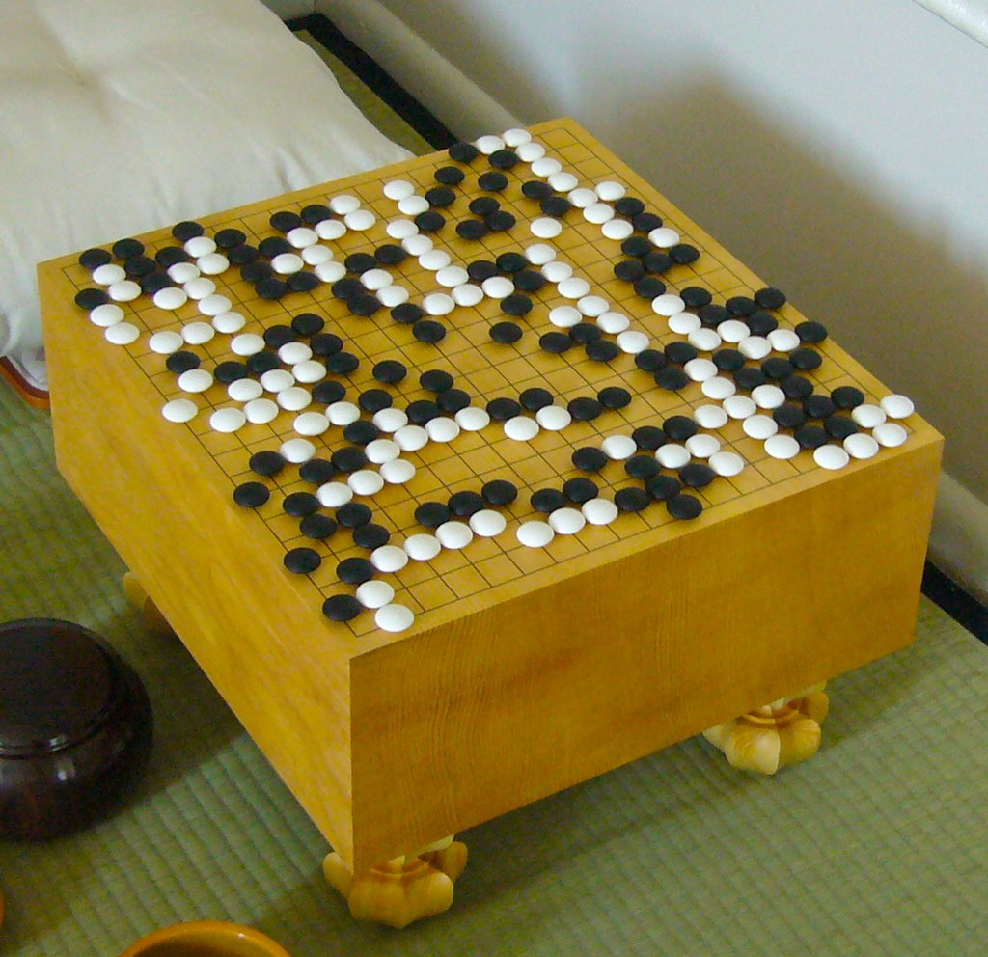

### **Figure 1**: Image of a Go game [1]. Figure captions are formatted like this one: numbered and beneath the image or diagram. If they are less than 1 line, they are centered, otherwise they are fully-justified. Slightly-smaller margins look nice but are optional (I used “heading 3” in this doc to auto-format margins).

# 2. PROCESS

(This section as a whole is typically the longest in your report by far.) In this section, your goal is to describe the overall process that you followed in enough depth that someone else familiar with basic image processing but not your problem could replicate your work without looking at your code. (You may include a line or two of code if helpful, but avoid just dumping code here - we are looking for MATLAB-independent details.) Include diagrams or other images as appropriate to make clear what you did, and if they are wide enough, they can span multiple columns, as shown in Figure 2. Justify the decisions you made. I suggest the following 4 sections, but you can split or merge them if you like. [One more note: most of the content of section 2 will be in the subsections, but you should alway have at least 1 sentence in a section before you start the first subsection. So say something brief as a manner of introduction.]

## 2.1 Data Source

{Describe the fruit photos briefly here.} The fruit photos are from the University of Rochester [1].

## 2.2 Preprocessing

Describe anything you needed to do to your data set before you could actually perform your experiments. Specifically talk about any color space conversion you did (like to HSV) and include an image.

## 2.2 Fruit pixel models

The thresholds used to extra pixels belonging to a fruit type forms a model to classify pixels of that fruit. In this section, give the thresholds you found and how you obtained them (likely iterating between observing the original images and the quality of the results). Of course, the same thresholds must be used on all images. Include the H, S, and V thresholds for each fruit type in a table and cite it (it probably will be Table 1).

### **Table 1**: HSV Thresholds. Note that unlike figure captions, table captions go above the table.

|  |  |  |  |
| --- | --- | --- | --- |
| **Fruit** | **Hue** | **Saturation** | **Value** |
| apple |  |  |  |
| orange |  | (complete this table) |  |
| banana |  |  |  |

Then, for mixed_fruit images 1-3, show the results of applying only those thresholds, before any other morphology or post-processing. Show the resulting masks of all of the 3 fruit models together on a single image. A good way to do this is to put each mask in a different band of a color image (with R = apple, G=orange, B=banana, for example). Show each image large enough to determine the detail - the width of a column and inline (easiest), or the 3 together spanning two columns (requires a bit more attention: if spanning 2 columns, it’s typical to move the text around so that the multi-column material is at the top or bottom of a page). Your goal here is to show that the thresholds between colors are reasonably accurate but likely not perfect (highlights will be misclassified, some background may be detected).

## 2.3 Morphology and post-processing

Most solutions will use some amount of morphology. State the exact morphological operators and structure elements and defend why you chose them). A table might be a good way to do this. Again, show the combined result masks for all 3 fruit types in a single image, and show all 3 mixed_fruit images.

If you did any other post-processing, like adaptively removing small regions or filling holes, then describe the process you used and show the final combined masks in the same way.

# 3. RESULTS

Include images with identification of fruit in the mixed_fruit images (not including fruit_tray). Again, just color the pixels that belong to each fruit type. Mark the centroid of each piece of fruit using a brightly-colored 3x3 square centered on the centroid.

Include a table that compares your counts to the expected counts. Also describe the quality of the results otherwise. You don’t need to calculate the accuracy of the centroids since you don’t know the true centroids (and I don’t expect you to hand-label them).

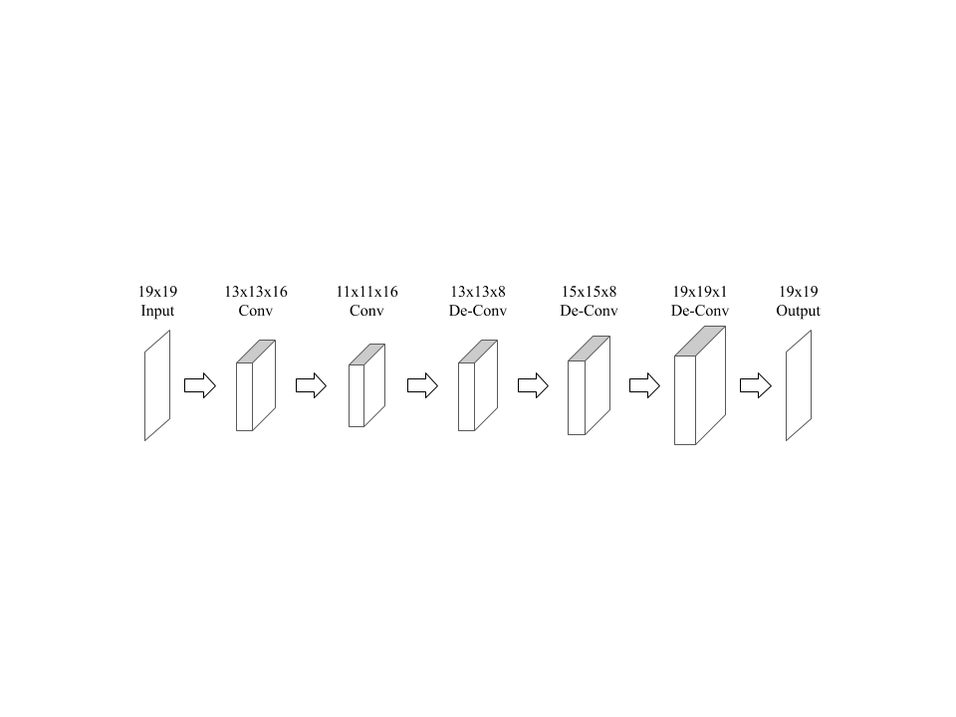

# Figure 2: The fully convolutional/deconvolutional architecture used initially.

# 4. DISCUSSION

This is the part where you interpret your results. Evaluate your system’s performance, both its strengths and its weaknesses. Give examples of both successes and failures of the system on the individual examples from the test set. Have you thought about the root causes of the successes and failures?

To help you consider one more source of variation, I included the fruit tray image, which will very likely cause your system to break. Present the final results of your system on the fruit tray and discuss those results and what about the image causes it to fail.

The company asked you to discuss how well your algorithm is expected to generalize to different environments. Consider what would be needed to move to a grocery store shelf or a conveyor belt in a packaging plant, for example, and hypothesize how your model would do. Specifically, think about those types of variation in fruit images that your system can handle and those that it cannot - you should discuss how it handles or doesn’t handle at least 3 types of variation (for example, fruit size due to camera distance from the fruit, and color due to lighting). For each, give either how it handles that variation or what changes you would need to make to handle that variation.

# 5. CONCLUSIONS AND FUTURE WORK

Start by summarizing your key findings. Then move on to the future. You only had a week or so to solve this problem. Tell what next steps you would take if you had another week or two to work on it. Then think bigger: what if you had a whole additional year to work on this problem as a research project - what major change would you make to your approach?

**REFERENCES**

[1] Images courtesy of Randal Nelson, Department of Computer Science, University of Rochester, accessed March 2006.

**APPENDIX**

You can include any extra details here that supplement the main flow of the work. If they are crucial to the flow of the paper though, include them in the paper’s body.

You must at least include your source code, though.

*{More instructions,* ***to DELETE before you convert to Word****:*

The first and foremost rule of professional writing is not to skimp on detail. Leaving it until the last minute is not an excuse to rush through a report.

*You will also be evaluated on:*

**Writing mechanics**: Is it free of typos and errors in writing mechanics: spelling, grammar and punctuation?

Proofread your paper slowly. It helps to have your partner proofread what you wrote and vice-versa. It should take 15-20 minutes to read carefully and note any errors – anything less and you are just skimming.

For any section written by non-native English speakers, we suggest having a native speaker help with this final step.

**Organization**: If you followed or adapted this standard template, you should be OK.

**Clarity, Conciseness, Professionalism**: Writing should be professional, clear and unambiguous, without exaggeration, and not unnecessarily wordy. Informal expressions and slang (e.g., “a lot”, second-person “you”) not used. Passive voice not used excessively. Specifically:

* *Don’t* use contractions. (I hope you appreciate the irony of this statement.)
* You are allowed to write in the first person, but write factually, not emotionally. Saying a result is “weird” or that you are happy it works is valid (and I welcome you to communicate that to me offline) but not appropriate for a formal paper. Also, don’t say that you “tweaked” parameters, rather that you “experimented with” them.
* Know when to use amount vs. number, less vs. fewer, and much vs. many.

A good, get- to-the-point resource for writing well is the Handbook for Technical Writers and Editors (<http://www.sti.nasa.gov/publish/sp7084.pdf>).

**Code**: Make sure your final code submission is submitted and documented.

**Aesthetics**: Make sure all figures, tables, and equations are large enough and colors clear enough to read easily. Each should have a number and be referenced by number in the text, even if it seems obvious which figure you would mean without the number. See the next paragraph. Spacing consistent. If you need a wide diagram that spans multiple columns, they look best on the top or bottom of a page; you will probably need to insert a section break before and after it so that you can set the number of columns differently on each section to make it happen. The right edge of the text should either be all justified, as in this report, or all left-aligned. See Word’s or google doc’s “align” button.

Always refer to figures, equations, and tables by number. For example, “Figure 6 shows the foo-ness of the bars. The resulting accuracy of the detector is greater than 90% (Table 2). We figured that out using Equation 1” And of course, include numbers in each caption. Equations do not need captions, just numbers to the right, as in:

(1)

When you are ready to submit it:

1. Convert to MS Word format. (Google docs are good for collaborative writing but Word is a better archival format, and we prefer it to pdf since we can easily add final comments and send them back to you at the end of the term.
2. Scan through it quickly looking for obvious formatting errors (a header on the bottom of a page, a figure or table that was split across columns or pages). Fix them. Then delete this final set of instructions from your report and submit it!

} % end instructions